**Difference between Scrum and XP:**

*Very* similar, but there are four subtle differences.

1. Scrums iterations are longer than XP; scrum works in sprints that are two weeks to a month, while XP’s sprints are one or two weeks long.
2. You cannot change the layout of sprints once you’ve started with Scrum. XP is a little more flexible, as long as you haven’t started the actual task, it’s subject to change.
3. XP has a strict priority order that they follow and is decided by the product owner, while the Scrum team gets to decide the order in which they design and develop.
4. Scrum doesn’t prescribe any engineering practices; XP does.

Software Quality may depend on *perspective*

How do you determine if it’s fast? Easy to use? You could have functioning code, but the “quality” has blurred lines. We consider quality as the product, the process, and the product in the context of the business environment.

We Relate the User’s view of quality to the Developer’s view by **McCall’s Quality Model**

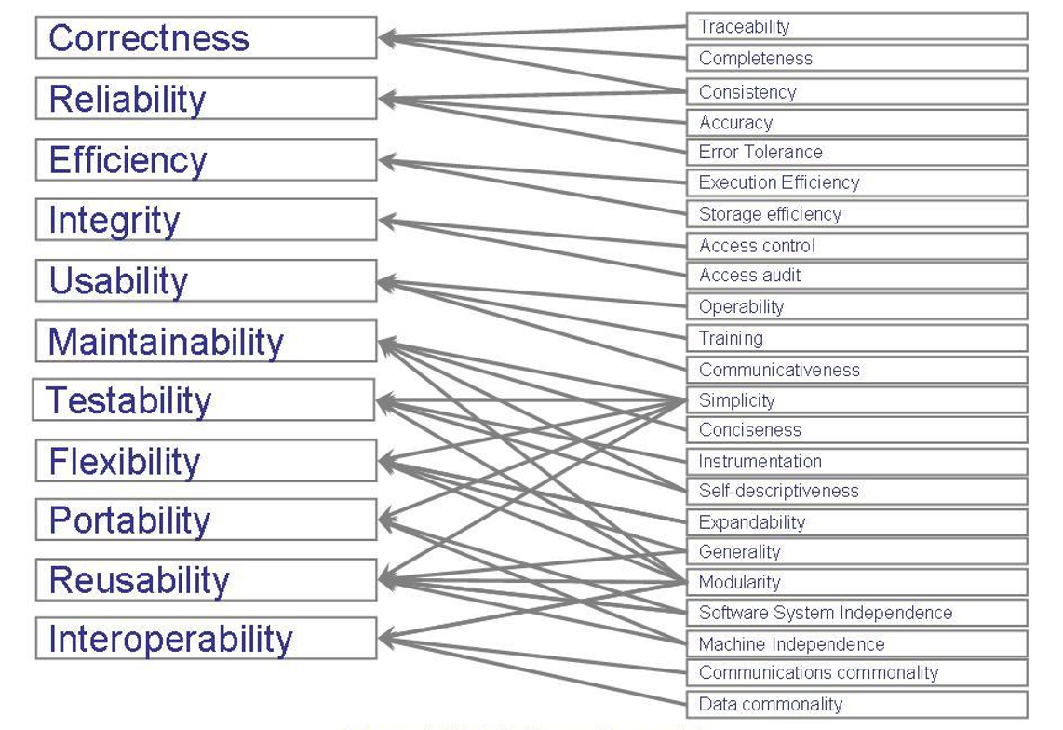

**Participants in a software development project**

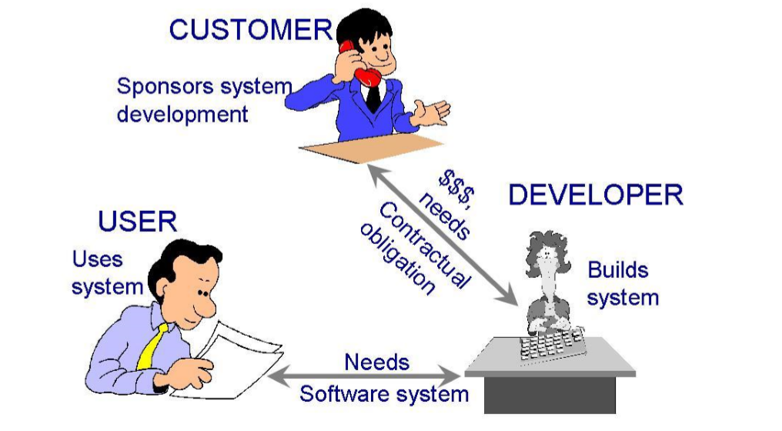

SYSTEM ENGINEERING:

Elements of a System

* Activities, an event initiated by a trigger, and Objects, elements involved in activities.
* Relationships that interact among objects and activities, and System Boundaries, which determines the origin of input and destinations of the output

*Compares it to a Respiratory System*

Entities are oxygen, nose, and lungs. Activities are inhale/exhale.